電通二甲微處理器實驗 實驗結報

實驗名稱 | Lab 08 –中斷控制與超音波測距
組別 |  | 組員 | 06050704/林智偉

- 實驗目的
Arduino 於 當按下 Pin 2 外部中斷 0 時, 讀入超音波測距 之值並顯示於 PC上
- 如何讀取超音波測距之值
- 如何將超音波測距之值顯示於 LCD?
- Arduino 如何規劃外部中斷 INT0?
4. 接一 SW, 當 SW 按下時暫停所有中斷, 實驗結果又如何?
- 實驗步驟
接好電路
打好程式碼
測試結果
- 程式碼
#1
#include <Ultrasonic.h>
#include <LiquidCrystal.h>
LiquidCrystal lcd(12, 11, 5, 4, 3, 2);
#define TRIGGER_PIN 9
#define ECHO_PIN 10
Ultrasonic ultrasonic(TRIGGER_PIN, ECHO_PIN);
void setup() {
Serial.begin(9600);
}
void loop(){
float cmMsec, inMsec;
long microsec = ultrasonic.timing();
cmMsec = ultrasonic.convert(microsec, Ultrasonic::CM);
inMsec = ultrasonic.convert(microsec, Ultrasonic::IN);
lcd.print("MS: "); lcd.print(microsec);
lcd.print(", CM: "); lcd.print(cmMsec);
lcd.print(", IN: "); lcd.println(inMsec);
delay(1000);
}

#2
#include <LiquidCrystal.h>
#include <Ultrasonic.h>
#define TRIGGER_PIN 9
#define ECHO_PIN 10
Ultrasonic ultrasonic(TRIGGER_PIN, ECHO_PIN);
LiquidCrystal lcd(12, 11, 5, 4, 3, 2);
void setup()
{
pinMode(6, INPUT_PULLUP);
lcd.begin(16,6);
attachInterrupt(6, int0, FALLING);
}
void loop()
{
}
void int0()
{
lcd.clear();
float cmMsec, inMsec;
long microsec = ultrasonic.timing();
cmMsec = ultrasonic.convert(microsec, Ultrasonic::CM);
lcd.print("CM:"); lcd.print(cmMsec);

}

#3
#include <LiquidCrystal.h>
#include <Ultrasonic.h>
#define TRIGGER_PIN 9
#define ECHO_PIN 10
Ultrasonic ultrasonic(TRIGGER_PIN, ECHO_PIN);
LiquidCrystal lcd(12, 11, 5, 4, 3, 2);
void setup()
{
pinMode(6,INPUT);
pinMode(7, INPUT_PULLUP);
lcd.begin(16, 2);
attachInterrupt(7, int0, FALLING);
}
void loop()
{
if(digitalRead(6))
{
noInterrupts();
}
else
{
interrupts();
}

}
void int0()
{
lcd.clear();
float cmMsec, inMsec;
long microsec = ultrasonic.timing();
cmMsec = ultrasonic.convert(microsec, Ultrasonic::CM);
lcd.print("CM:"); lcd.print(cmMsec);

}

- 實驗結果及分析
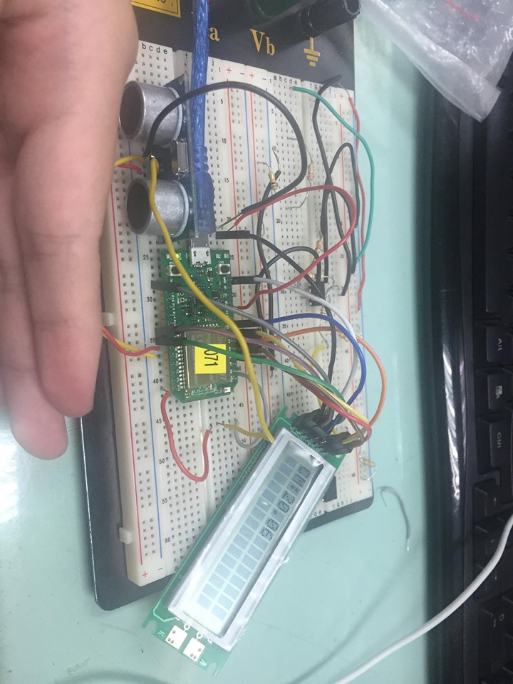
- 心得討論
這次的實驗有點難，拖了有點久才做出來，要好好加油了。

